1. Read the question and the student’s answer carefully.
2. Use the mark scheme to award the student a number of marks and annotate their answer with suggestions to improve.
Stretch: Rewrite the answer to show how it should be done!

Question:
A student tried to extract lead and aluminium from their ores by heating lead oxide and aluminium oxide with carbon in a fume cupboard.
They were able to obtain lead from lead oxide but not aluminium from aluminium oxide.
Explain why.
(3)
Student answer:
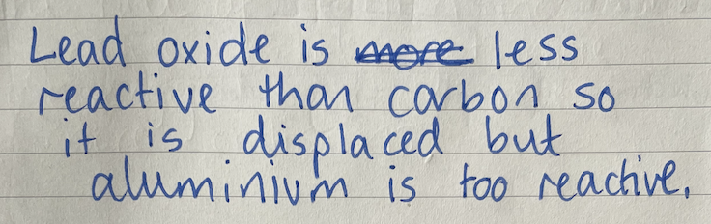

Marks awarded= _________

Mark scheme:

Answer | Mark
Lead is below carbon in the reactivity series  Allow converse statement  Do not allow lead oxide | 1
Aluminium is above carbon in the reactivity series  Allow converse statement  Do not allow lead oxide | 1
Carbon can displace lead (from its oxide) but not aluminium | 1

